
SWC3623: WEB APPLICATION DEVELOPMENT
SESSION: AUG – NOV 2025
PROJECT BRIEF

Student’s Name | ID No.
YASIERUL FIRDAUS BIN AZIZAN | AM2405015974

Project Title
Car Rental Booking System

Aim/Objectives

To develop a web-based Car Rental Booking System that allows users to reserve vehicles online and enables administrators to manage car availability and bookings efficiently.

-To design a user-friendly interface for browsing and booking cars online.
-To implement user authentication for customers and administrators.
-To develop a booking module that calculates rental price based on duration.
-To enable administrators to manage car listings and monitor reservations.
-To integrate a database system for storing and retrieving user, car, and booking information.

Description
The Car Rental Booking System is a web-based application designed to simplify the process of renting cars online. Customers can create an account, log in, browse available cars, and make bookings by selecting their preferred vehicle along with pick-up and return dates. The system automatically calculates the rental cost based on the duration and stores the information in a secure database. Administrators can log in to manage car listings, update vehicle availability, and monitor booking records. This project integrates both frontend and backend technologies to provide an efficient and user-friendly solution for car rental services.

Target User
The primary target users of this system are customers, including travelers, students, and working individuals, who require vehicles for temporary use and prefer a convenient online reservation process. Additionally, the system targets car rental administrators who manage vehicle listings, monitor bookings, and ensure smooth rental operations.

Site’s Organization
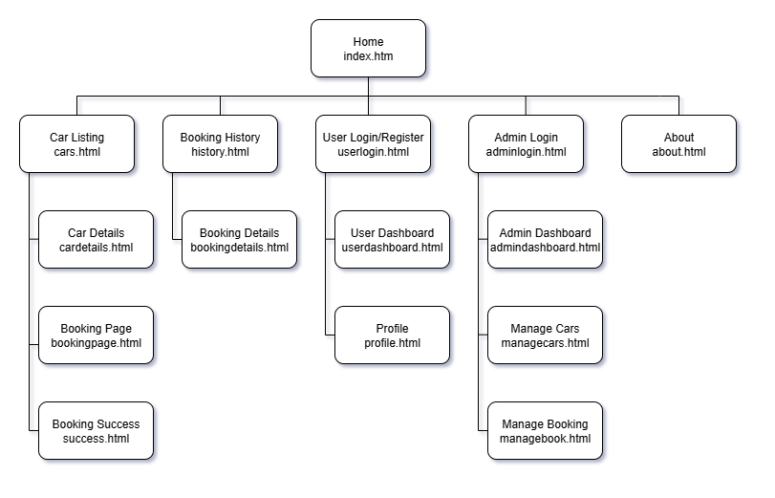

Date of submission: 18 AUGUST 2025 (WEEK 3)

